Notice

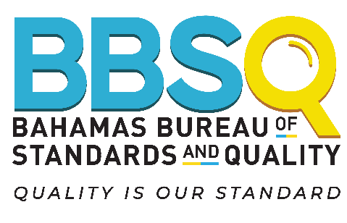

Re: Public Comment on Draft Bahamas National Standards

The Bahamas Bureau of Standards and Quality (BBSQ) is mandated to develop, adopt and promulgate standards for such goods and services as may be required in the national interest.

The following Draft Bahamas National Standards are being issued for public comments, in accordance with the provisions set out in the Standards Act, Chapter 338 (2006), and in keeping with international best practices and the standards development procedures:

- DBNS SLCP 13-5:2022 Code of Hygienic Practice for Beauty & Wellness – Part 5: Particular Requirements for Nail Establishments

DBNS | Draft Bahamas National Standard

Copies of the DBNS (Draft Bahamas National Standards) are available for viewing virtually on The Government’s website: www.bahamas.gov.bs.

Please submit your comments in writing to:

Dr. Renae Ferguson-Bufford Bahamas Bureau of Standards and Quality
P.O. Box N-4843 Nassau, N.P. Bahamas
Email: info@bbsq.bs Telephone: (242) 362-1748 thru 55

The deadline date for submission of comments on the above Draft Bahamas National Standards for adoption is the 31st of May, 2024

