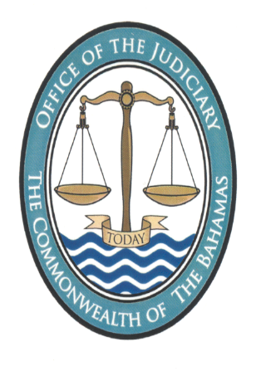
NOTICE
Pursuant to section 8 of the Juries (Amendment) Act, 2014, the Revising Panel shall sit to hear objections to the 2024 Jury List on 4th December 2023 from 10:00 am to 1:00 p.m., and from 3:00 p.m. to 6:00 p.m. on the said date at the Supreme Court Hansard Building, Bank Lane.
A hard copy of the proposed 2024 Jury List together with this accompanying Notice is available for inspection by any member of the public during weekdays between the hours of 9:30 am to 4:30 pm at the Chambers of The Hon. Madame Senior Justice Cheryl Grant Thompson located on the ground floor Justice Supreme Court Annex 1 (formerly Ansbacher House) situate at Bank Lane, Nassau. Persons wishing to inspect the Jury List may do so by attending at the Chambers of The Hon. Madame Senior Justice Cheryl Grant Thompson. In addition, the said Jury List will also be available on the Judiciary’s website at www.bahamasjudiciary.com

Registrar
The Supreme Court
15th November 2023

